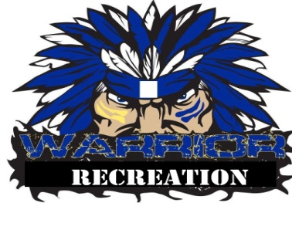
MANASQUAN RECREATION CODE OF CONDUCT POLICY

The Manasquan Beach and Recreation Department has adopted the Rutgers University Youth Sports Research Council’s Model Athletic Code of Conduct. This policy is promulgated in accordance with the State of New Jersey provisions of P.L. 2002, Chapter 74. Please read the policy in its entirety and sign/date at the bottom.

Preamble:
Interscholastic and youth sports programs play an important role in promoting the physical, social and emotional development of children. It is therefore essential for parents, coaches and officials to encourage youth athletes to embrace the values of good sportsmanship. Moreover, adults involved in youth sports events should be models of good sportsmanship and should lead by example by demonstrating fairness, respect and self control.
I therefore pledge to be responsible for my words and actions while attending, coaching, officiating or participating in a youth sports event and shall conform my behavior to the following code of conduct:
- I will not engage in unsportsmanlike conduct with any coach, parent, player, participant, official or any other attendee.
- I will not encourage my child, or any other person, to engage in unsportsmanlike conduct with any coach, parent, player, participant, official or any other attendee.
- I will not engage in any behavior which would endanger the health, safety or well being of any coach, parent, player, participant, official or any other attendee.
- I will not encourage my child, or any other person, to engage in any behavior which would endanger the health, safety or well being of any coach, parent, player, participant, official or any other attendee.
- I will not use drugs or alcohol while at a youth sports event and will not attend, coach, officiate or participate in a youth sports event while under the influence of drugs or alcohol.
- I will not permit my child, or encourage any other person, to use drugs or alcohol at a youth sports event and will not permit my child, or encourage any other person, to attend, coach, officiate or participate in a youth sports event while under the influence of drugs or alcohol.
- I will not engage in the use of profanity.
- I will not encourage my child, or any other person, to engage in the use of profanity.
- I will treat any coach, parent, player, participant, official or any other attendee with respect regardless of race, creed, color, national origin, sex, sexual orientation or ability.
- I will encourage my child to treat any coach, parent, player, participant, official or any other attendee with respect regardless of race, creed, color, national origin, sex, sexual orientation or ability.
- will not engage in verbal or physical threats or abuse aimed at any coach, parent, player, participant, official or any other attendee.
- I will not encourage my child, or any other person, to engage in verbal or physical threats or abuse aimed at any coach, parent, player, participant, official or any other attendee.
- I will not initiate a fight or scuffle with any coach, parent, player, participant, official or any other attendee.
- I will not encourage my child, or any other person, to initiate a fight or scuffle with any coach, parent, player, participant, official or any other attendee.
I hereby agree that if I fail to conform my conduct to the foregoing while attending, coaching, officiating or participating in a youth sports event I will be subject to disciplinary action, including but not limited to the following in any order or combination:
- Verbal warning issued by a league, organization or school official.
- Written warning issued by a league, organization or school official.
- Suspension or immediate ejection from a youth sports event issued by a league, organization or school official who is authorized to issue such suspension or ejection by a school board or youth sports organization.
- Suspension from multiple youth sports events issued by a league, organization or school official who is authorized to issue such suspension by a school board or youth sports organization.
- Season suspension or multiple season suspension issued by a school board or youth sports organization.

