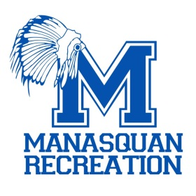

**“Friends and Family” CPR Classes**

**Manasquan Recreation is teaming up with the Manasquan First Aid Squad to offer “Friends and Family” CPR classes! Our first aid volunteers will also cover basic first aid to include handling a choking victim. The 90- minute class will be held at the DCI Building/Rec Annex at 67 Atlantic Avenue on Saturday, December 4th from 10:30 to 12pm and is being offered to anyone age 13 and up. Class size is limited to 12 so sign up fast! An additional session will be added if needed. The cost of the class is $5. Please contact Erik Ertle at #732-223-0544 X260 or email at** [**eertle@manasquan-nj.gov**](mailto:eertle@manasquan-nj.gov) **to reserve a spot!**

**Manasquan First Aid Squad, Inc.**

Serving since 1929

