Do Pilates
at the Beach!
Sponsored by Manasquan Recreation

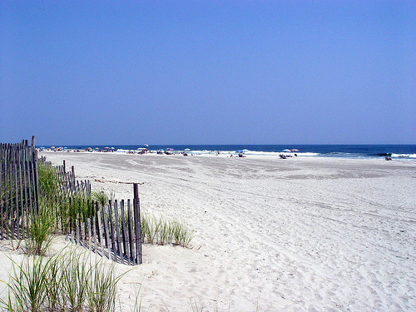
Oh yeah, it’s a workout that’s as crazy or as easy as you need it to be.
All levels welcome.
7:30 – 8:30 a.m. Thursdays, Elks Beach. July 11, 18, 25; Aug.1, 8, 15
Bring $10 per class and a towel.
Pilates on the beach is fun! It’s good for you.
Just like the beach itself!
Call Theresa at 914-960-9214 if you have any questions.
See you at the beach!

